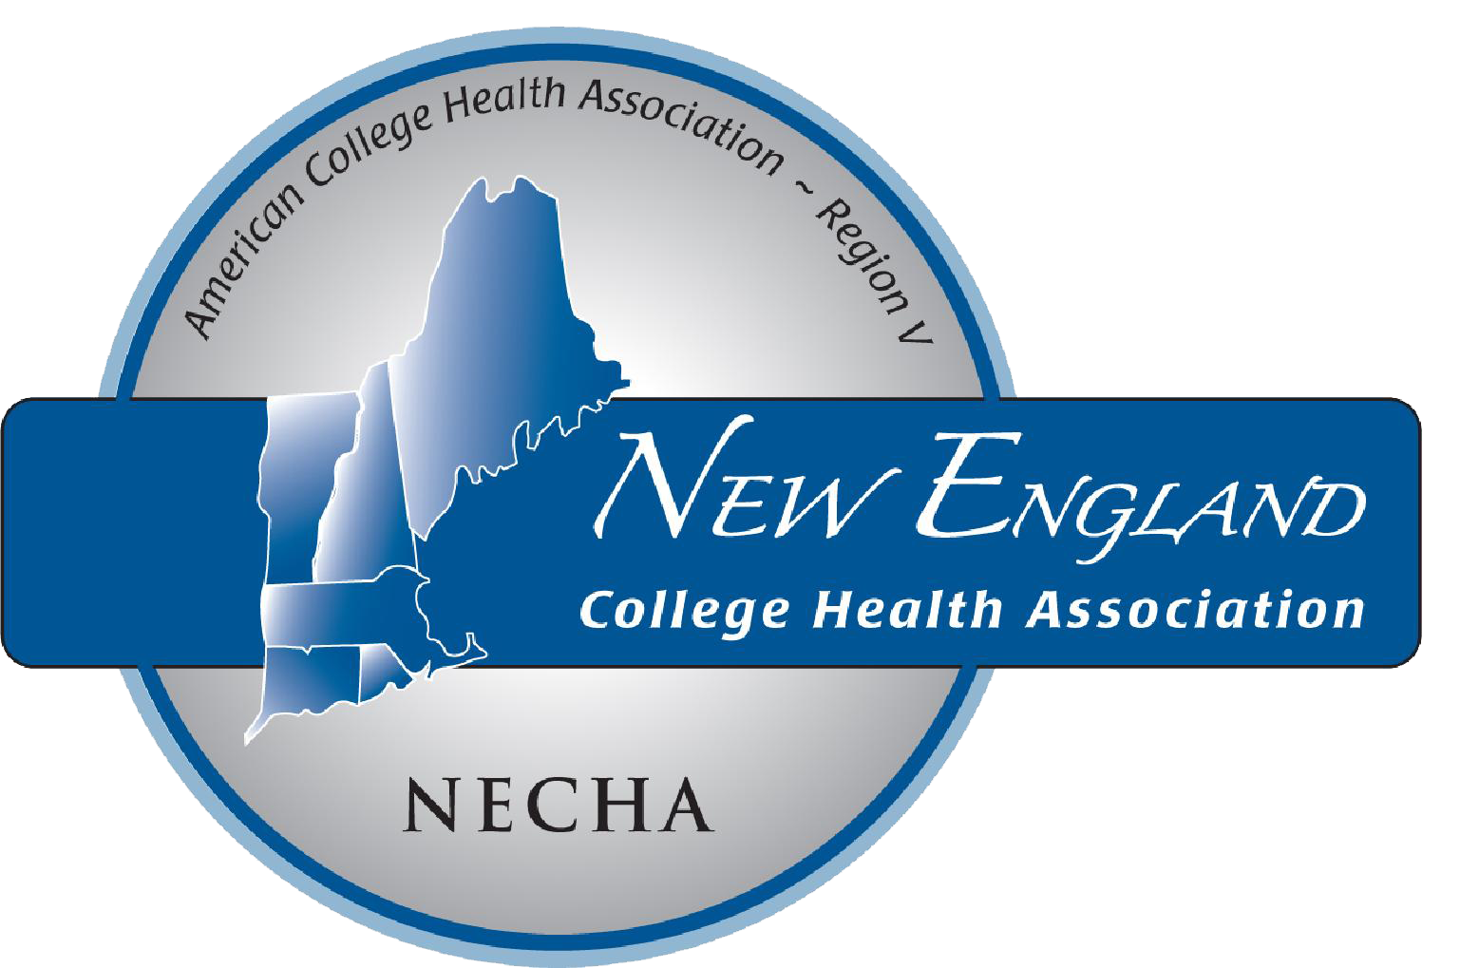
NECHA 2021
Louise Gazzara Award
Nominate a Colleague!

Do you know an outstanding college health nurse who has made exceptional contributions to their students, institution, and the field of college health?
If so, please consider nominating him or her for NECHA’s Louise Gazzara Award.
For consideration, nominees need not be an ACHA individual member, but must currently work in college health.
Nomination deadline is Tuesday, June 15, 2021
(See Nomination Form and further direction on the following page).

Louise Gazzara Award
This award honors a college health nurse who has made outstanding contributions to NECHA,
her/his college or university, and the profession. The award was originally established by CHAND
(College Health Association of Nurse Directors) in 1992 to honor Louise Gazzara on the occasion of her retirement after 25 distinguished years as Director of Nursing at Tufts University. Louise was also a longstanding member
of NECHA, serving as president in 1982, and ACHA. In 2000, NECHA assumed responsibility for the
Louise Gazzara Award, continuing to use the criteria established by CHAND.

Past Recipients

- 2019: Margaret Leonard, RN, Bates College
- 2018: Wendy Sansone, RN, MSN, Bowdoin College
- 2017: Margaret Fitzgerald, MS, FNP-BC, Bentley University
- 2016: Mary Lou Walsh, ANP-BC Mount Ida College
- 2015: Joan Ecklund, BSN, RN Wesleyan University
- 2014: Gerri Taylor, MS, ANP-BC Bentley University
- 2013: Kathryn Macaione, BSN, RN (posthumously) Connecticut College
- 2012: Barbara Germain, RN College of the Holy Cross
- 2011: no nominations this year; none awarded
- 2010: Karen O’Brien, RN, BSN Rhode Island School of Design
- 2009: Catherine Kelleher, RN Providence College
- 2008: Kathy Savage, RN Tufts University
- 2007: Debora Cain, RNC College of the Holy Cross
- 2006: Nancy Barry, RNC Merrimack College
- 2005: Mary Kay Connell, BS, CPNP Salve Regina University
- 2004: Rita Sheppard, RNC Babson College
- 2003: Gail Langley, RNC Wellesley College
- 2002: Betty Cotter, MS, RNC and Sandra Stern, RNC, ANP Bryant University, Anna Maria College
- 2001: Charlene 'Charley' Bradley, RNC Dartmouth College
- 2000: Carole Worsh, RN-C, ANP Pine Manor College

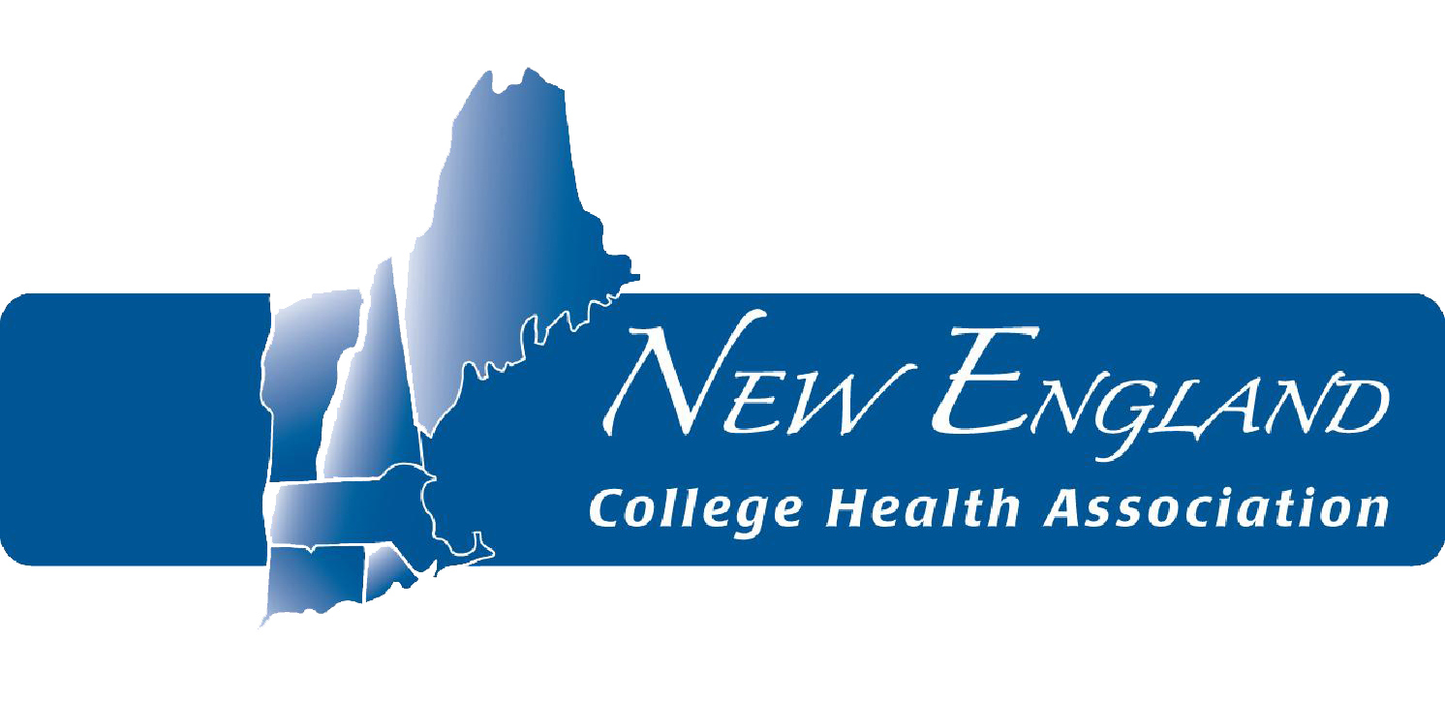

2021 Louise Gazzara Award

Nomination Form

Name of Nominated Individual, Credentials:
Position Title:
Institution:
Mailing Address:
City
State
Zip Code
Telephone:
Email:

Nominee's # of years and capacity of service
to college health within NECHA and/or ACHA:
Significant contributions to the field of college health, NECHA and/or ACHA: Outstanding qualities of professional and personal character; significant professional accomplishments:

Name of Nominator:
Position Title:
Institution:
Mailing Address:
City
State
Zip Code
Telephone:
Email:

Are you?...(please check all that apply) | Yes | No
Individual ACHA/NECHA member?
Employed at an ACHA/ NECHA member institution?
Please attach a letter(s) of support to the nomination form to provide the committee with more detailed information and comments.

Submit by Tuesday, June 15, 2021 to: Elizabeth Drexler-Hines, MPH, MCHES NECHA 2021 Awards Chair

