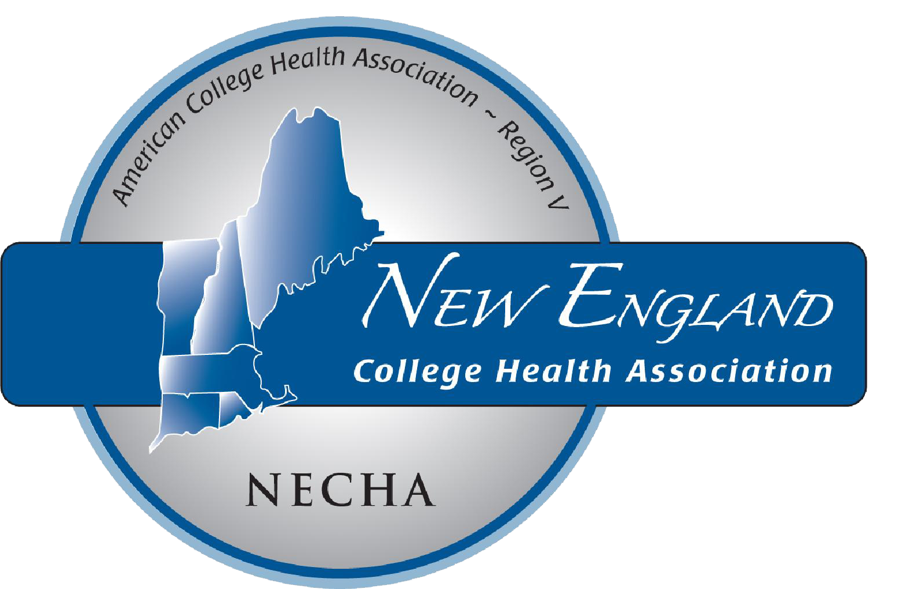
NECHA 2019
President’s Award
Nominate a Colleague!

Do you know an outstanding college health colleague who has made exceptional contributions to their students, institution, and the field of college health? If so, please consider nominating him or her for NECHA’s highest honor, the President’s Award.

For consideration, nominees need not be an ACHA individual member, but must currently work in college health.

Nomination deadline is September 15, 2019
(See Nomination Form and further direction on the following page).
NECHA President’s Award
Established in 2001, the President’s award recognizes the contributions to College Health by an individual working in the field from the states of Connecticut, Maine, Massachusetts, New Hampshire, Rhode Island, or Vermont. The individual selected should have made significant contributions to the students they serve as well as their institution, and the field of college health. The nominee should be a creative, innovative, dedicated leader and mentor, known for their sharing and caring. This award represents the highest recognition given by the New England College Health Association.

Past Recipients
- 2018: Bryant Ford, PhD, Dartmouth College
- 2017: Bruce Churchill, MD, Harvard University
- 2016: Vanessa Britto, MD, MSc Wellesley College
- 2015: Michael Kurland, MSPH University of Connecticut
- 2014: Cheryl Flynn, MD University of Vermont
- 2013: Margaret Higham, MD Tufts University
- 2012: Joleen Nevers, MAEd, CHES, AASECT University of Connecticut
- 2011: Constance Hiller, MD Brown University
- 2010: John Miner, MD Williams College
- 2009: Charlene ‘Charley’ Bradley, RN, BC Dartmouth College
- 2008: Peter Davis Smith, MD Wesleyan University
- 2007: Ryan Travia, MEd Harvard University
- 2006: Peter Nobes, PA University of Vermont
- 2005: Cynthia A. Lubianez, RN, MS Boston College
- 2004: Lillian Zanchi, RNC University of Maine
- 2002: Chad Henderson, MBA University of Rhode Island
- 2001: Yolanda Baumgartner, MBA Dartmouth College
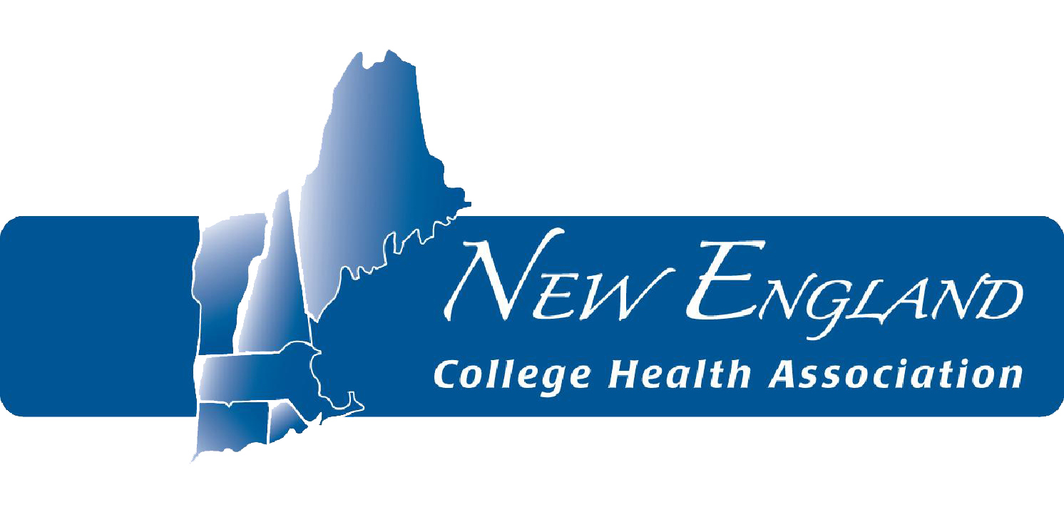

2019 President’s Award Nomination Form

Name of Nominated Individual, Credentials:
Position Title:
Institution:
Mailing Address:
City
State
Zip Code
Telephone:
Email:

Years and capacity of service to college health,
NECHA and/or ACHA:
Significant contributions to the field of college health, NECHA and/or ACHA: Outstanding qualities of professional and personal character; significant professional accomplishments:

Name of Nominator:
Position Title:
Institution:
Mailing Address:
City
State
Zip Code
Telephone:
Email:

Are you?...(please check all that apply) | Yes | No
Individual ACHA/NECHA member?
Employed at an ACHA/ NECHA member institution?

In addition to this form, please include a letter(s) of support to provide the committee with more
detailed information and comments about the nominee.

Submit by September 15, 2019 to:
Jessica Greher Traue, EdM
NECHA 2018 Awards Chair

